Engineering Report

Spyglass Illumination LED

Calibration Procedure

Prepared for

Boston Scientific

By

Enercon Technologies

12-31-2014

Prepared by:

J. Peterson

# Overview

The Spyglass Digital Controller features an Automatic Illumination Control (ALC) system that adjusts the illumination LED output dynamically, providing optimal lighting to achieve proper image density for each frame in the video stream. The LEDs are controlled programmatically via a 16-bit Digital-Analog-Converter (DAC). Each LED/controller pair has a unique mapping between the DAC input and the light output. More specifically, each has a unique point at which light begins to be produced at a usable level.

Without a well-defined low-end shutoff point, the ALC algorithm may overshoot the optimal illumination level at low LED levels, causing bounce or even oscillations of the illumination. Therefore, a normalized shutoff point is needed for proper operation of the ALC algorithm.

The LEDs must not be driven at more than 5.25 amps. To back-up the hardware safeguards, an upper calibration value is established to prevent the ALC from requesting LED output levels that would draw more than 5.25 amps.

The high and low cutoff calibration values define a normalized linear mapping from the full 16-bit range [0, 65535] to the limited DAC input range [CL, CH], where CL and CH are the low and high cutoff values established for a given LED/controller pair. In this way the ALC can never drive the LED either too high, risking equipment damage, or too low, causing unstable illumination control.

Once established the LED calibration values are stored in the Spyglass controller’s non-volatile memory. They are read from the non-volatile memory during the controller startup sequence and are applied thereafter whenever the ALC algorithm requests an illumination change.

# Calibration Procedure

A calibration procedure will be run on every controller during production. The procedure is run prior to the installation of the controller cover, after all other components are installed, and the firmware is installed. This provides the necessary access to the controller’s diagnostic serial port.

To eliminate human subjectivity and to minimize errors, the calibration itself is performed by a computer program that communicates with the controller via the serial connection to the controller’s diagnostic port. The program takes advantage of the controller’s built-in diagnostic commands for establishing the calibration values and for storing them in the controller.

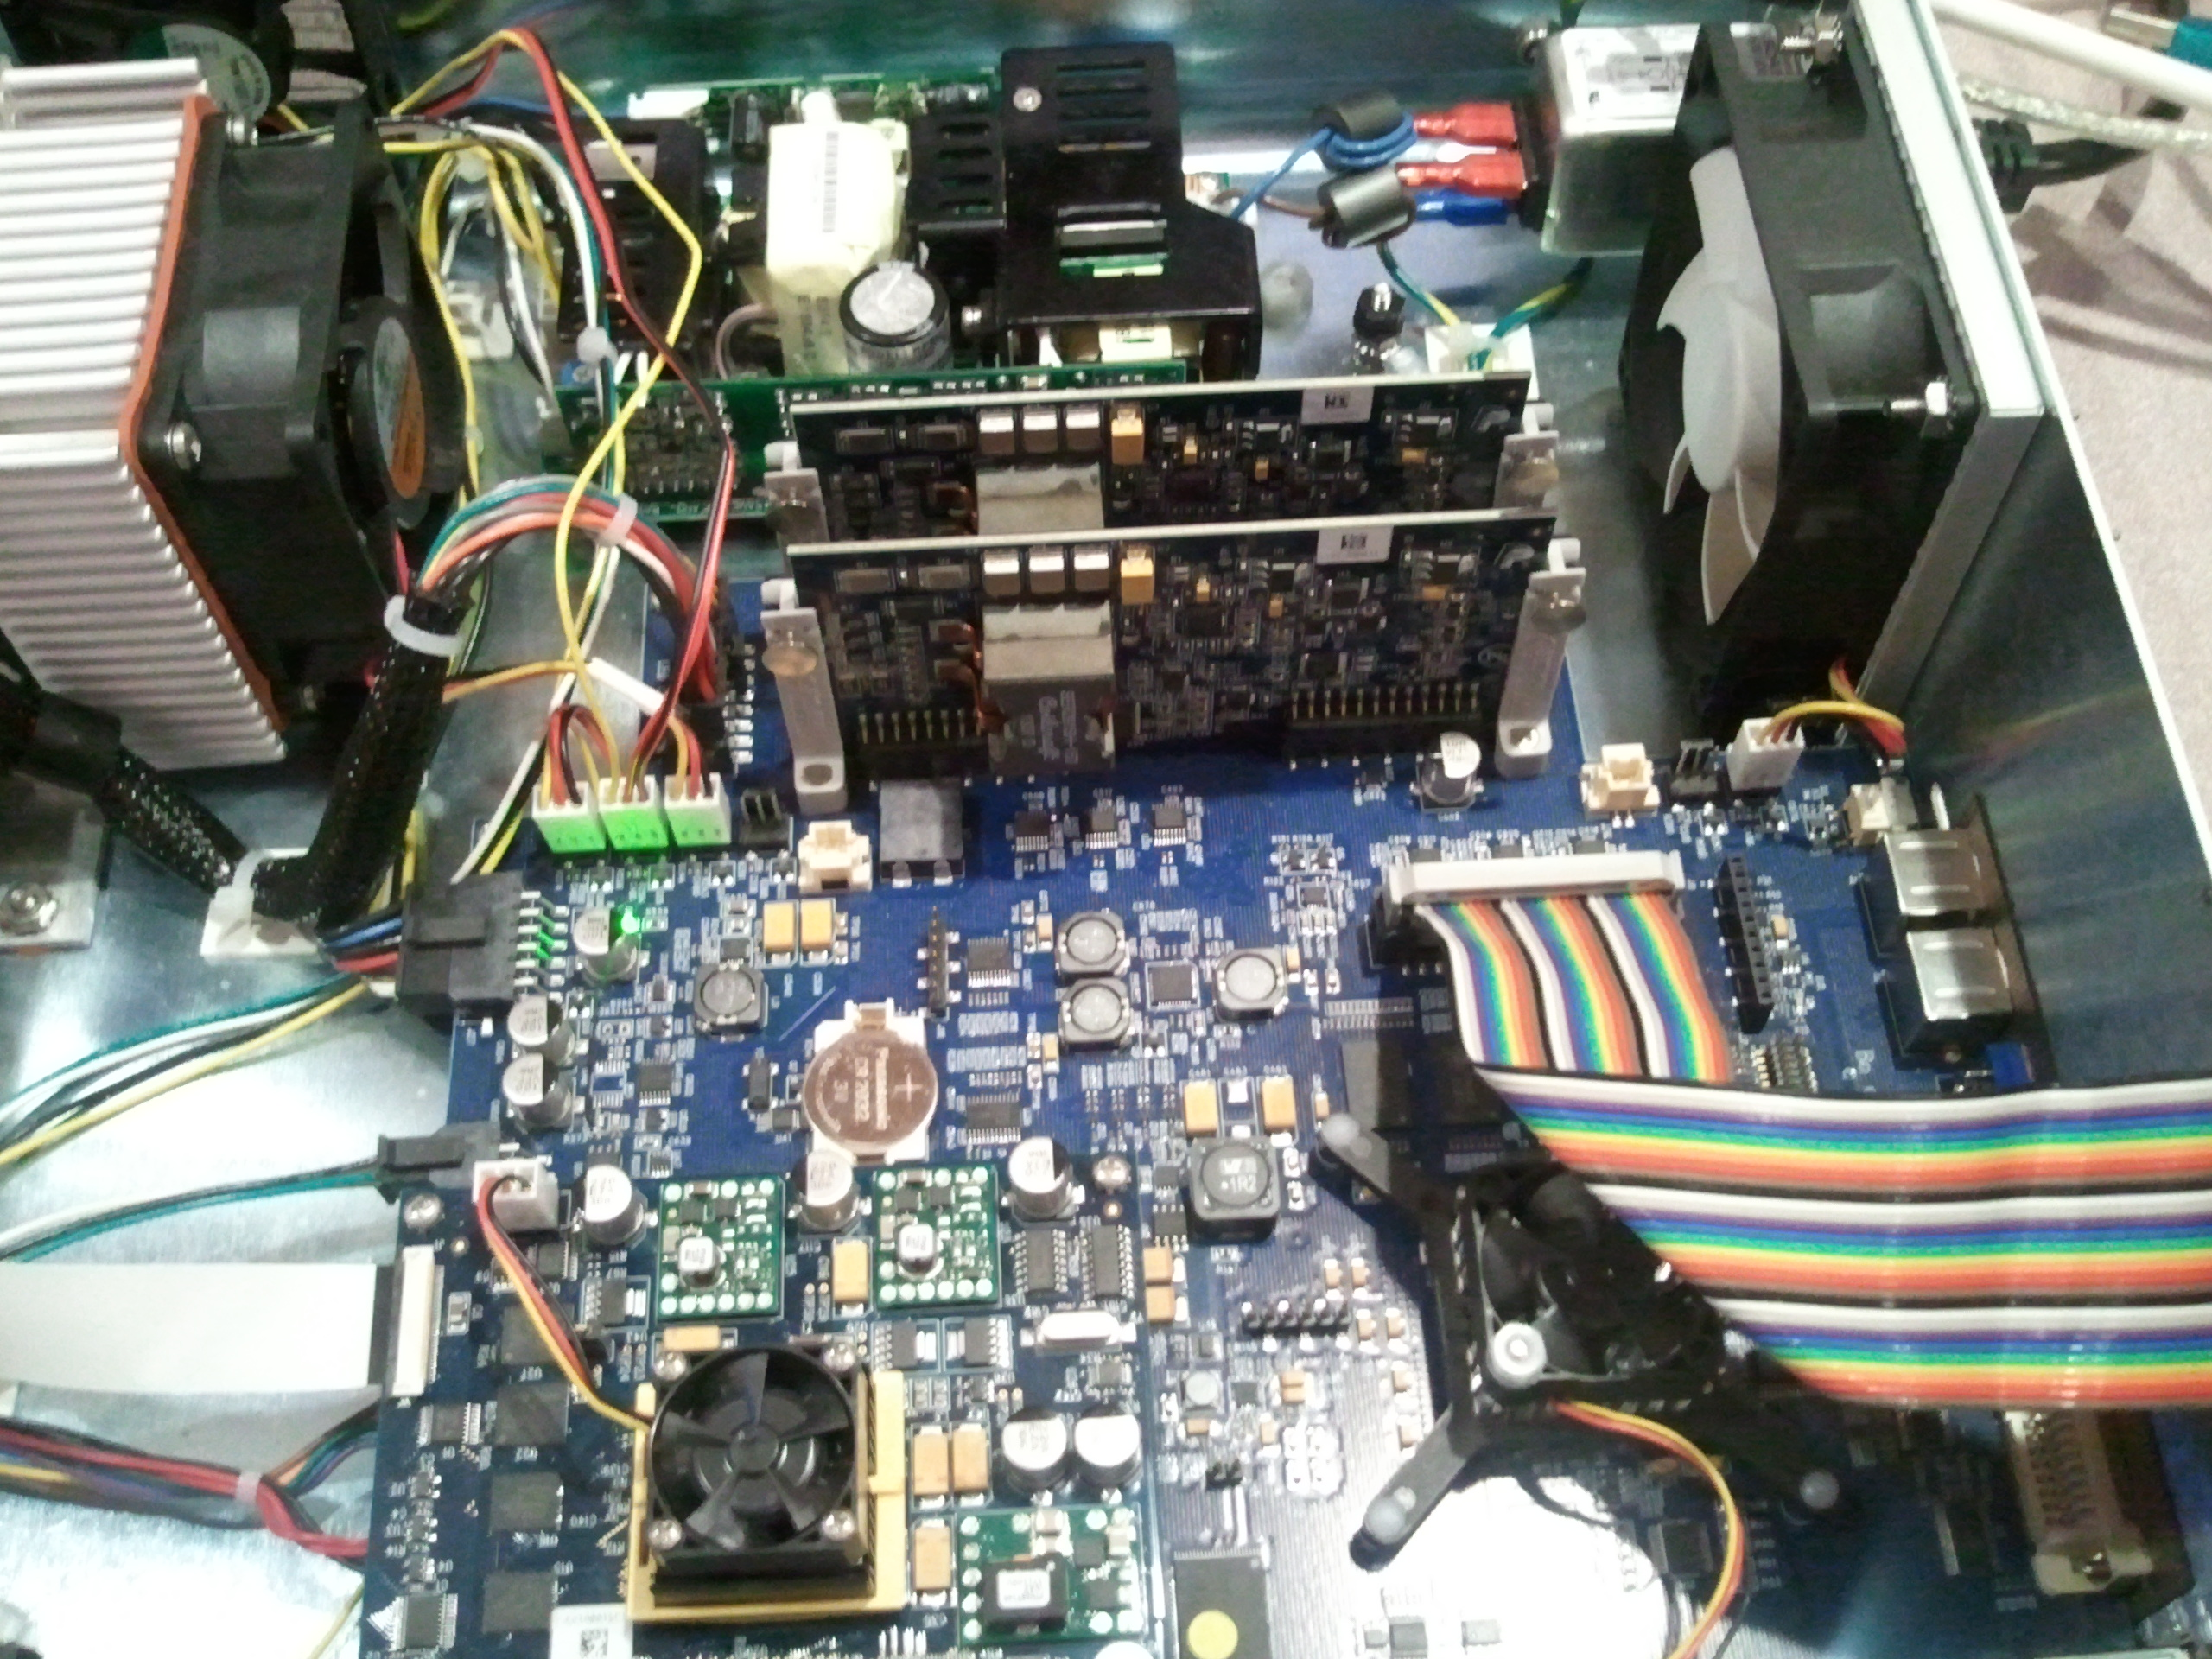

diagnostics serial port

to host computer

The operator steps for calibration consist of the following:

1. Connect the host computer to the Controller via a special diagnostics serial port.
2. Start the controller as usual.
3. Connect the scope to the controller and insert the tip into the calibration fixture.
4. Start the calibration program on the host computer and select the serial port connected to the diagnostics port.
5. Initiate the calibration procedure and wait for the procedure to terminate.

Errors will be reported to the operator for the following conditions:

* Unable to open serial port – This may indicate a physical disconnect in the serial line.
* Unable to establish connection to the Controller – This may indicate that either the Controller failed to start or that the serial cable is connected to the wrong serial port in the Controller.
* Calibration values out of range - This may indicate that the scope has not been inserted into the fixture or that there is a hardware issue with the light engine.
* Unable to parse the responses from the controller – This would indicate an unspecified internal error with the controller.

# Fixture Design

The calibration is performed with the use of a standard scope inserted into a special fixture. The fixture consists of a light-tight housing into which the tip of the scope is inserted. A fixed distance from the tip is a reflective surface that reflects the light from the illumination fibers back to the image sensor.

Light-tight box

Image sensor

Reflective surface

Illumination fibers

The distance from the scope tip to the reflective surface is the minimal distance such that there is no loss of light beyond the field of view of the camera. In this way, the majority of the light from the fiber is reflected back to the sensor, and the image of the fiber covers minimal area on the sensor image. This allows minimal output from the LEDs to be measureable by the sensor.

In air the camera has a horizontal field of view (FOV) of 90 degrees. In air, the fiber optic illuminators project light with an angle width of 69 degrees.

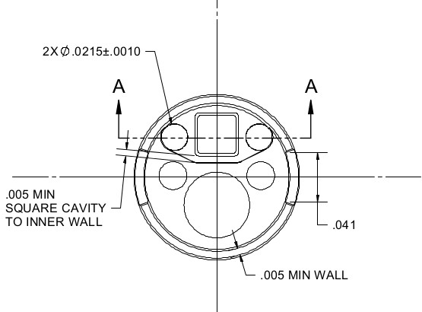

Image Sensor

Illumination Fiber

Illumination Fiber

The diagram above shows the orientation of the sensor and the illumination fibers. The illumination fibers are located on either side of the image sensor spaced about 0.7 mm from the center of the sensor. The desired distance to the reflective surface can be computed as the point of intersection of the outermost spread of the illumination and the horizontal FOV of the camera. This is illustrated in the diagram below.

D=2.25 mm

0.7 mm

reflective surface

Illumination spread

(69 degrees)

Camera horizontal FOV

(90 degrees)

illumination fiber

image sensor

55.5°

45°

The intersection occurs when:

$\tan\left(55.5°\right)=\frac{D}{(D-0.7)}$

or

$$D=\frac{(0.7mm)∙\tan{(55.5°)}}{\left(\tan{(55.5°)}-1\right)}≈2.25mm$$

Therefore, the minimal distance to the reflective surface is 2.25 mm. Adding a small margin for error, the fixture will be designed with a stop that will place the scope tip at a distance of 2.5 mm from the reflective surface. The reflective surface will be designed to be flat to eliminate the need for any particular orientation of the scope in the fixture. The minimum size of the reflective surface is $2\sqrt{2}∙D$ mm square for the sensor in any rotational orientation relative to the reflector. A safe design size for the reflector is then a 15 mm square.

The following is a summary of the key features of the calibration fixture:

* **Light-Tight Housing** – The light-tight housing prevents external light from illuminating the sensor when identifying the low-end cutoff points. It also serves to protect the operator from bright light when identifying the high-end cutoff points.
* **Flat Reflective Surface** – The 15 mm square flat reflective surface is key for identifying the low-end calibration values.
* **Internal Stop** – An internal stop positions the tip of the scope with the image sensor 2.5 mm from the reflective screen.

# Calibration Program

The calibration program will have a graphical user interface to simplify the use by the operator and to minimize the misinterpretation of the results. The results will also be logged along with the Controller serial number.

All command responses will be parsed to ensure that the commands are processed as expected by the controller. The following is a list of example commands that will be used, along with their responses.

To reduce the traffic on the serial line:

>> disable_events=1

<< Events disabled

To disable the image processing parameters:

>> cc_reset

<< 2014-12-24 00:43:17.095 [0x00171418] DEBUG *  - DSP: contrast: type=none

>> gamma=1

<< 2014-12-24 00:43:47.343 [0x00171418] DEBUG *  - DSP: gamma=1.000

>> r=1

<< 2014-12-24 00:44:21.033 [0x00171418] DEBUG *  - DSP: r=1.000

>> g=1

<< 2014-12-24 00:44:23.474 [0x00171418] DEBUG *  - DSP: g=1.000

>> b=1

<< 2014-12-24 00:44:25.828 [0x00171418] DEBUG *  - DSP: b=1.000

To monitor the current drawn:

>> ledvi

<< LED Driver V1: 2.0718, I1: 0.0649, V2: 2.3658, I2: 0.0641

To set the LED DAC levels:

>> led_dac=0,3452

<< LED DAC levels set: LED_1=0  LED_2=3452

>> led_dac=3874,0

<< LED DAC levels set: LED_1=3874  LED_2=0

To monitor the exposure:

>> em_style=0

<< ALC debug output style set: 0

>> em=-1

<< target=-1 average=87 LED-1:[exposure=86 DAC=3752(normalized=0)] LED-2:[exposure=89…

<<   86   86   85   85   84

<<   88   90   90   87   85

<<   91   92   91   90   87

<<   92   91   91   87   85

<<   90   87   85   84   84

To retrieve the current calibration values:

>> led_cal

<< LED Calibration: LED-1(low=3752  high=61089)  LED-2(low=3352  high=60747)

To set the calibration values:

>> led_cal,1,3752,61089

<< LED Calibration: LED-1(low=3752  high=61089)  LED-2(low=3352  high=60747)

>> led_cal,2,3352,60747

<< LED Calibration: LED-1(low=3752  high=61089)  LED-2(low=3352  high=60747)

For improved performance, the convergence to the calibration values will be done in two steps. First, a fast rough estimate is found by stepping the DAC level by 32. Second a final value will be determined by stepping the DAC by single units.

There can be as much as a two frame latency between when the LED output is changed to when the exposure is reported. This will be taken into account when programmatically setting the DAC and reading the subsequent exposure change.

# Establishing the High-end Cutoff

The high-end cutoff point is established by monitoring the DAC’s internal current and voltage while adjusting the DAC input value. The calibration value will be set to the lowest DAC input value at which 5.25 amps of current are drawn by the DAC. This procedure is performed while a standard scope is connected to the controller. During the procedure the tip of the scope is confined to the light-tight fixture to protect against operator eye damage.

The DAC value is adjusted using the diagnostics command “led_dac=*d1*,*d2”*, where *d1* and *d2* are in the range [0, 65535], with each parameter controlling the respective LED. The following is an example of the command and the controller’s response:

led_dac=0,64038

LED DAC levels set: LED_1=0  LED_2=64038

The current is monitored with the “ledvi” command. The following is an example of the controller command and response:

ledvi

LED Driver V1: 2.0718, I1: 0.0649, V2: 2.3658, I2: 4.6341

The current drawn by the LED controllers is listed in the response as “I1” an “I2. The units are amps. The upper calibration values are established independently, one LED at a time.

# Establishing the Low-end Cutoff

The low-end cutoff point is established by monitoring the image intensity while adjusting the DAC input value. The calibration value will be set to the highest DAC input value for which no illumination is measurable by the scope image sensor. While set to this low-end value the illumination LEDs may emit a faint glow, however, the illumination will be unusable by the sensor.

The image intensity is monitored using the controller’s diagnostic command that reports the exposure of the 5 exposure zones. Since the exposure is measured after the basic image processing is performed, the contrast curve is disabled and the gamma correction is set to 1.0. The noise level is first established by setting the DAC input to 0 and monitoring the exposure. The following is an example of the “em=-1” diagnostics command and the controller’s response:

em=-1

target=-1 average=87 LED-1:[exposure=86 DAC=3752(normalized=0)] LED-2:[exposure=89…

   86   86   85   85   84

   88   90   90   87   85

   91   92   91   90   87

   92   91   91   87   85

   90   87   85   84   84

The numbers in the grid in the command response above are the average pixel intensities of the 25 exposure zones. The low-end calibration value is the highest DAC input value before the 25 exposure zones begin increasing from the base recorded with the LEDs turned off.

Saving the Calibration Data

After successfully establishing the calibration values for both LEDs, the values are written to the controller’s non-volatile memory. The diagnostic command used to store the data is:

Led_cal,<LED-number>,<low-cutoff>,<low-cutoff>

Any errors in storing the data will be reported to the operator. When successfully written the data will also be logged along with the controller serial number.